Catalog PR creation steps:
In order to raise a PO (Purchase Order), you need to create a PR (Purchase Requisition) first. When you purchase an item through BuyNow a PR is raised, this is sent for approval and once approved it becomes a PO.
1. Login to BuyNow<https://s1.ariba.com/gb/?realm=accenture&locale=en_GB> (Ariba)Type in the goods/service/supplier needed. You will be provided with our preferred supplier catalogs you can purchase from
2. Browse the various catalog's and select the required item. (NB. If your item is not listed in the Catalog, you can raise an adhoc request, follow this process - How do I purchase a non catalog item?)
3. Add the item to your cart to begin the create a Purchase Requisition (PR) process.
4. Continue shopping or ‘Checkout’
5. The Purchase Requisition (PR) code for your order is in the top right of the screen
6. Complete all the mandatory fields, such as ‘charge code’, ‘shipping details’, areas specific to your country, etc
7. Add comments if required
8. Once completed, click ‘send request’ (top of the screen)
9. This will automatically send your purchase requisition for approval
Note: If the Purchase Requisition is for more than $1000 (US & UK Only), approval will be required from a Business Approver. (The requestor of the PR cannot be the Business Approver). Update the Business Approver, click on 'Submit' once all the details are updated.
For more information on how to buy something in BuyNow (Ariba), please watch this 10 minute training video - BuyNow - Want to buyhttps://mediaexchange.accenture.com/media/t/0_6ycl23oe
Please find the below screen shots:
- Login to BuyNow Link using your Login Credentials.

- Click on Catalog, select one of the available catalog as per the below image. You can either select the categories specific to the purchase or just enter the keyword and search for the catalog.
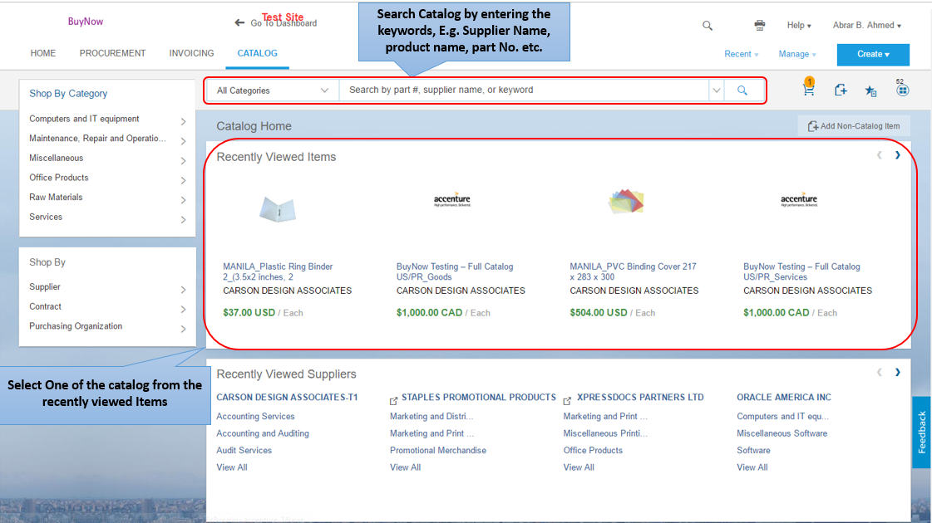

- Once you select the Catalog the selected item will be displayed. Update the required quantity and click on ‘Add to cart’ to proceed with the purchase.

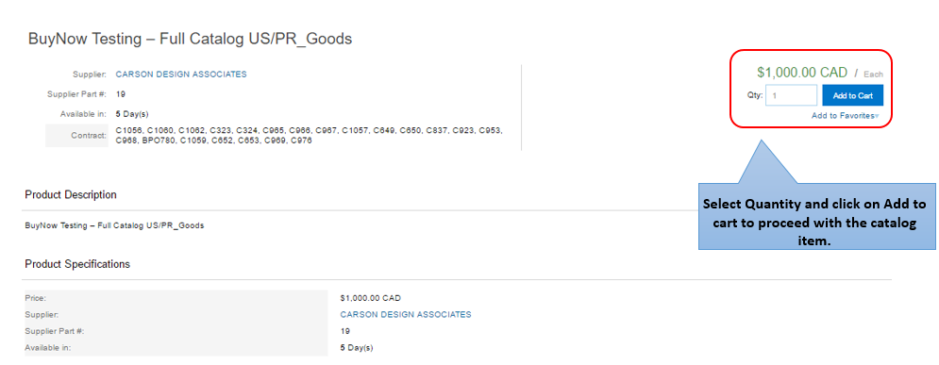

- Click on Proceed to checkout to update/edit line item.
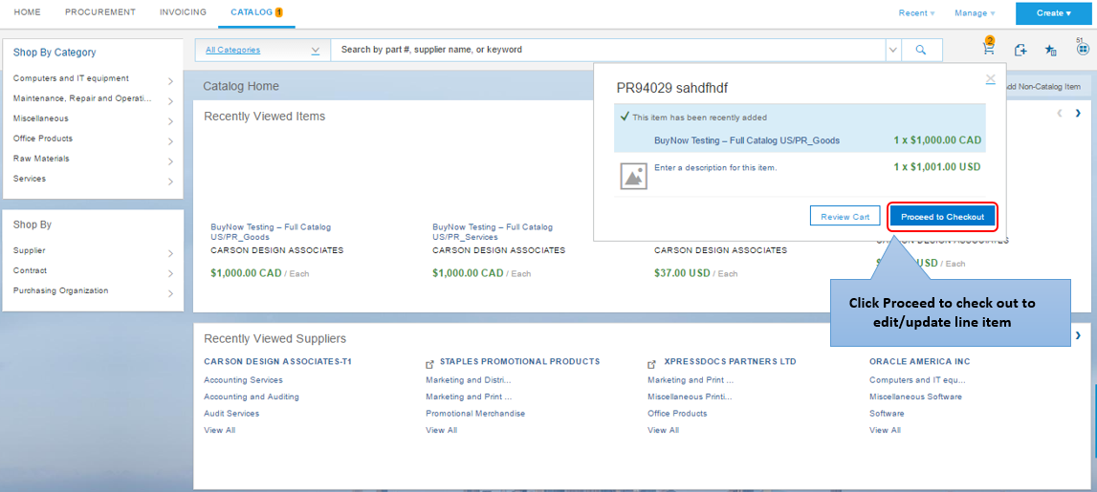

- Click on Actions Button and select Edit from the drop-down options.

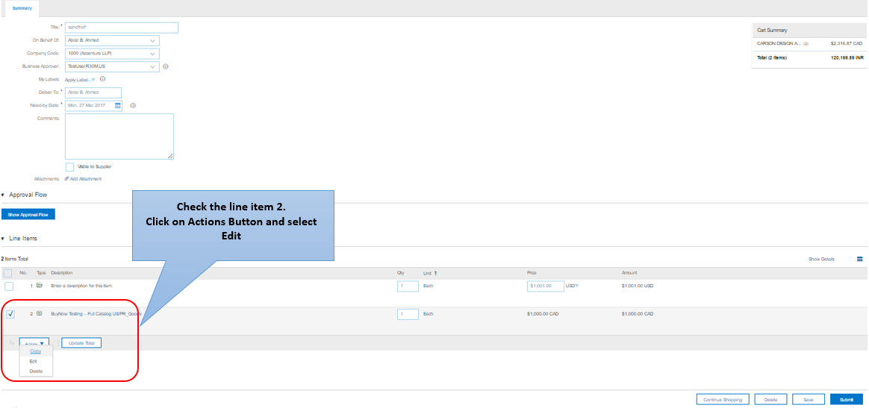

Vi. Update the account assignment, billing address, GL code accordingly.
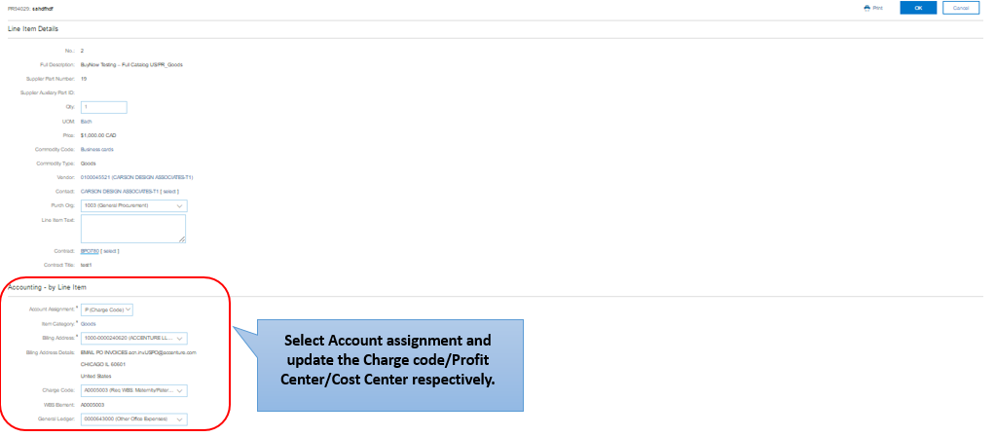

Vii. Update the Deliver Address, need by date and click on Ok to complete the Line Item.

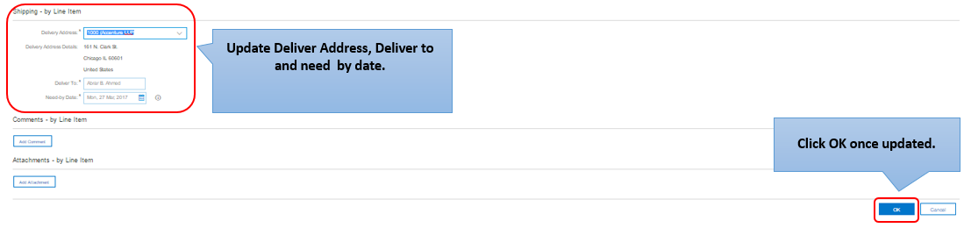

Viii. BuyNow will now take you back to the first page where you will have to update On Behalf of, Business Approver, deliver to (Deliver Address), GFMD, CFO (if require), Business Justification etc. Once all the details are updated click on Submit.
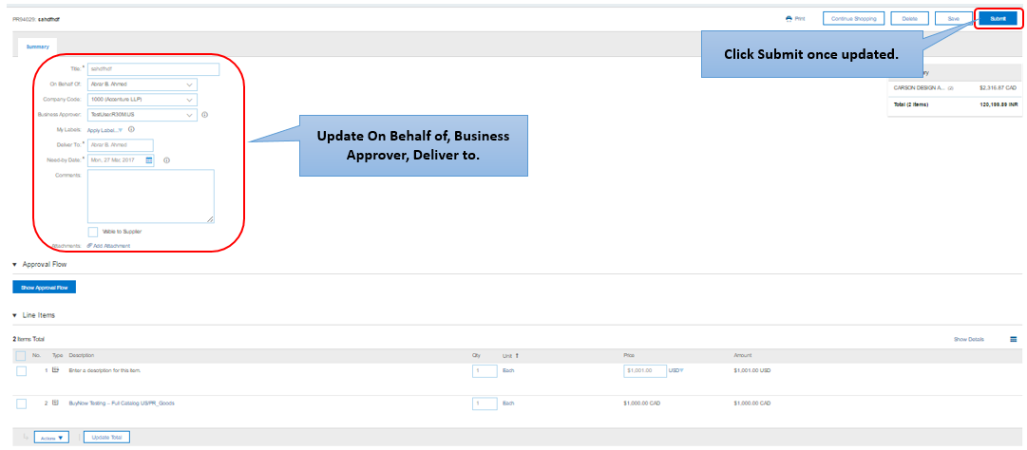

- You can now click on the View Requisition to get the submitted PR number.

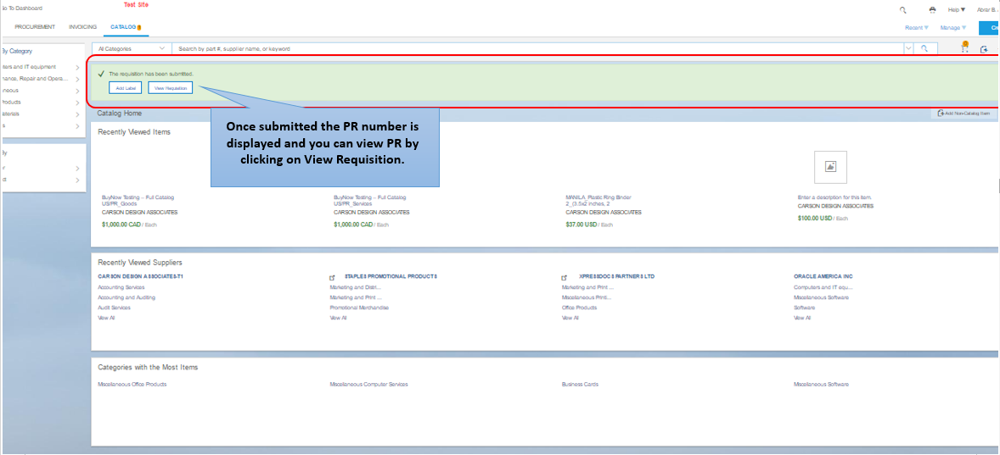

Non catalog PR creation steps:
1: Login to Buy Now via https://buynow-p2p.accenture.com/
2: Once logged in please check if the default currency is updated as per the country currency for which PR needs to be raised by clicking on profile initials on the top right corner > Change default local option > click on create option which is on the top right > click on requisition.
3: Update the title and company code, need by date and click on continue shopping. Click on add non catalog item which is to the right below the cart symbol.
4: Once clicked on NON catalog item please update the purchase organization and update the full description, commodity code, quantity, price amount and vendor name and click on add to cart.
Note: If the commodity type is service then the quantity should always remain 1.
5: Once clicked on add to cart please update the business approver and scroll down to the bottom and select the 1st line item and click on actions edit which is in the bottom left.
6: Update the charge code (WBS) or profit center or cost center and the delivery address and click on ok.
7: Update the business approver which is the 4th option from the top.
Note: If the amount is more that 10k USD business approver career level should be 7 and above and the approval limit should be more that 10k USD
8: Once all the details are updated you can click on submit to submit the PR.
9: Once submitted it will undergo approval process and once approved PO will be generated.

Please find the below screen shots:
- Login to BuyNow Link using your Login Credentials.

- Click on Create dropdown and select requisition.

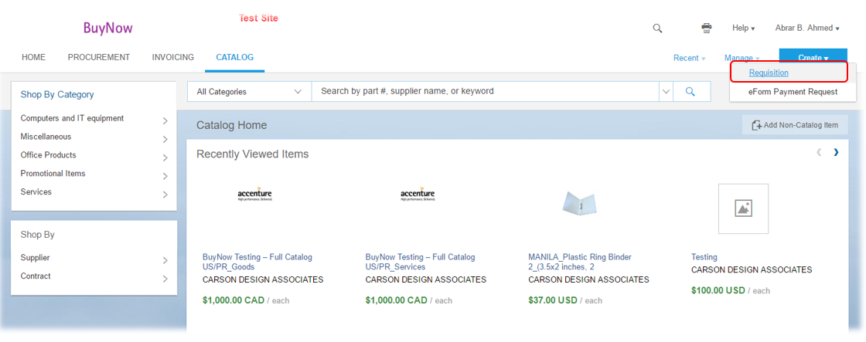

- Fill the required details as highlighted below and click on ‘Continue Shopping’
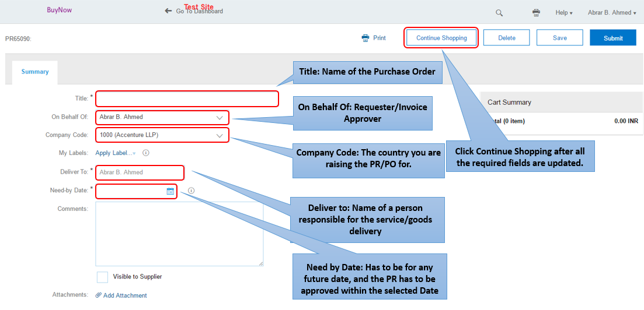

- Click on Add Non-Catalog Item Button or the Icon highlighted below to create a Line Non-Catalog Item.

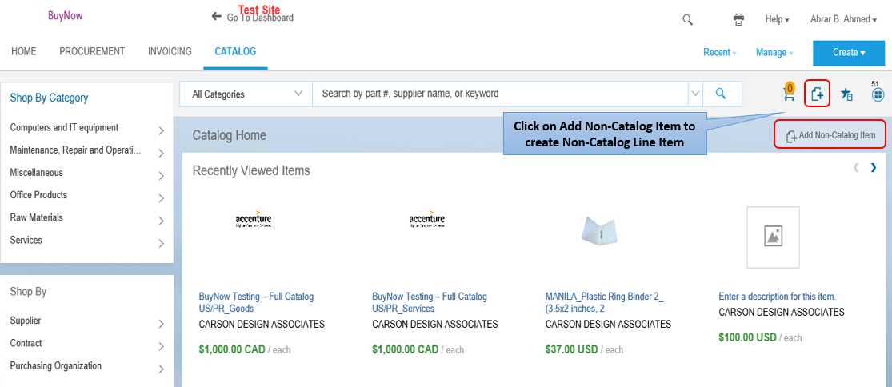

- Update the required details highlighted below with the description and click on Add to Cart.

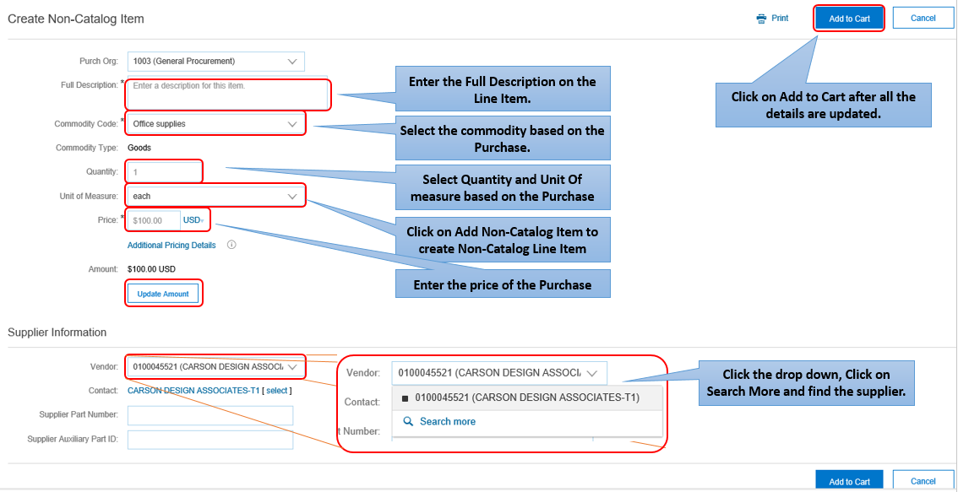

- Click on Proceed to Checkout

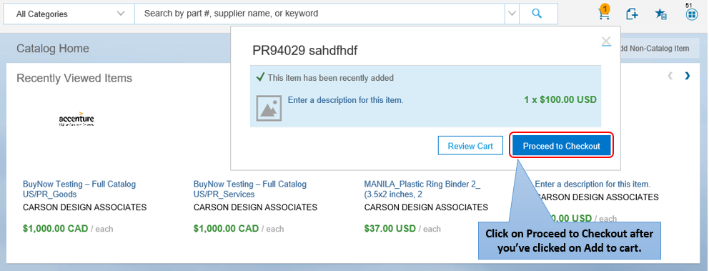

- Once the Proceed to check out button is selected the below fields will be visible which has to be updated.
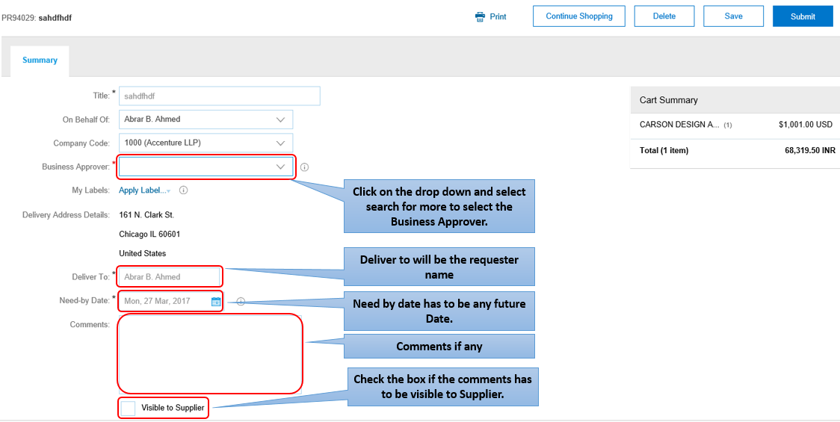
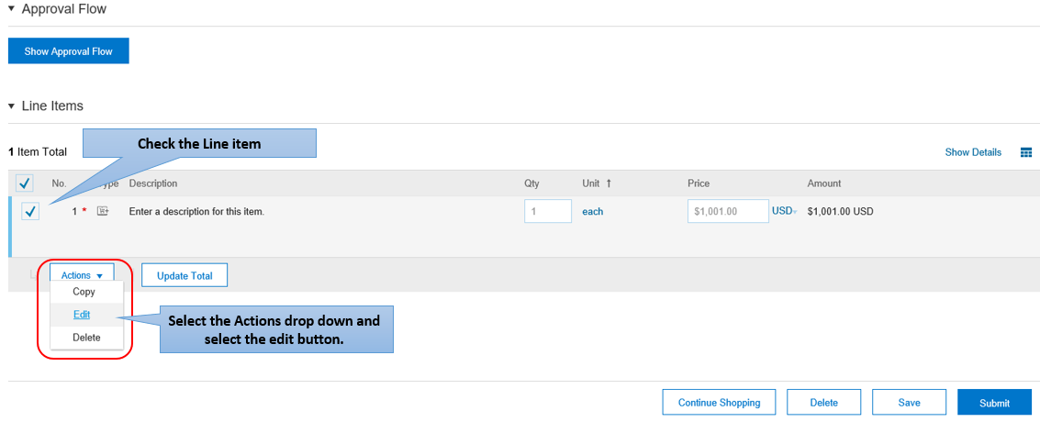

- Once you select the Edit, Buy now will take you to the Line Item details in which the required information including Account Assignment and General Ledger has to be updated. Scroll down and click the “Ok” button to complete the Line Item.
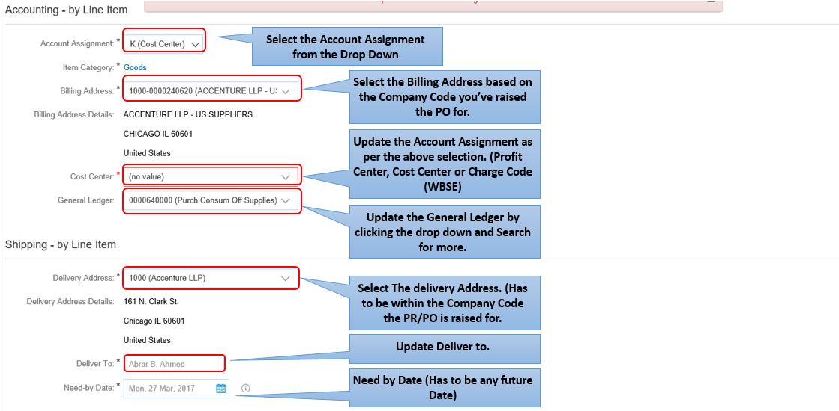

- After clicking Ok, BuyNow will take you back to the PR creation page where you can either click on “Continue Shopping” to add more line items or Click on “Submit” to complete the PR creation.

